

The below named individual has been accepted into the Dental Assisting Program. Your cooperation in performing a dental examination and completing this form will assist the student and the dental assisting program.

Name of Student: ______________________________________________________________
Last Name First Name Middle Name

Address: ______________________________________________________________________
______________________________________________________________________
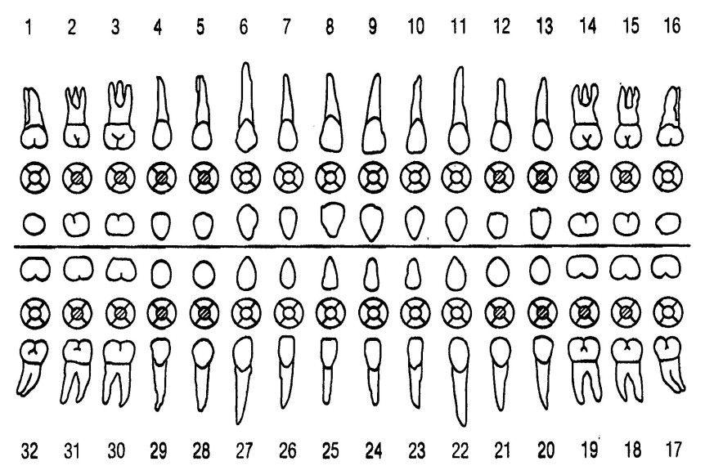
Phone Number: ________________________________________________________________

How often are teeth examined? ________________________________________

Care of mouth: Good Fair Poor

Care of teeth: Good Fair Poor

Occlusion: Good Fair Poor

Periodontal condition:

Gingiva: _______________________________________
Bone: ________________________________________
Mobility: ____________________ Pockets: ______________
Recession: ___________________

Recommendations: __________________________________________________
_________________________________________________________________________________________________________________________________________________________________________________________________________
Date: __________________
Dentist/Practice Name: __________________________
Dentist Signature: ______________________________
Address: ____________________________________________

