Early Childhood Education
Textbooks

Textbooks will be purchased by the Lancaster County Career and Technology Center and will be available to students as needed throughout the school year. Students in the Early Childhood Education program will NOT need to purchase textbooks. The following three texts will be provided to students after the drop/add period. Students who complete the course will be allowed to take the books with them for use in their future careers or college experiences

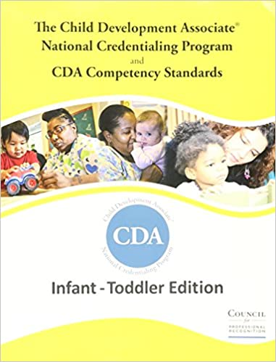
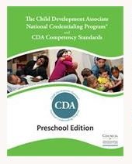

OR

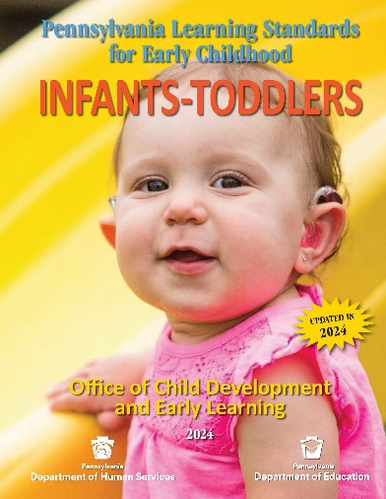 AND 